**Color Sorting Robot**

**Introduction:**

The ability to differentiate colours is essential for human’s life as it gives us the

awareness about the changes in surrounding .Moreover, byexploiting the ability of colour capture, intelligent machine gains the function todifferentiate, sort and organise. The project includes sensors that detect colour ofthe object then sends the information to Arduino Uno which in turn adjusts theservo motor which located just below the ball slider to move it left and right.

Based upon the colour detected, the slider will move according to the angle of

10°, 70° and 170° depends on the object colour. The stations are in red, green and blue respectively. After every ball placement, the slide will go back to its defaultangle position, awaiting the next colour ball.

In many cases, the interactions of a few robots are needed to carry out

certain task, whereby it is crucial to fully control robots to operate at level which isdesired . This colour sorting robot is developed with the purpose of minimisingthe cost, optimising the productivity and reducing human mistakes.

The objectives of this project are summarised as below:

* To write color recognizing and color sorting code.
* To integrate color recognizing, sorting and motor with microcontroller.
* To test the code and troubleshoot with the efficiency of the system.
* To sort objects according to their respective colours and stations accordingly.

**The significance of the work:**

The challenge often occurred in industry that involves colour sorting system suchas diamonds industry or food industry such as separation of rice, coffee, and othercereals that could be solved via this project. The first factor is speed of sorting.

The speed of colour sorting process by an operator is very slow. This is due to thelimitation of response time for a human eye . The eyes will always take sometime to see an image and project this to the brain to initiate visual sensation. Afterthe brain has received the image, it will take some time for the brain to determinethe colour of the object too . However, this limitation can be covered by using a computer. In this project, Arduino Uno, the microcontroller is used to increase the speed of color sorting.

The other challenge is the accuracy of colour sorting process by an operator is very low in current industry. This is because an operator will need to handle hundreds or thousands of objects each day, tiredness will usually cause some faultwhen colour is being divided or sorted. It is very common for an operator to make this error. However, a machine will not have this problem. A machine will giveaccurate result even after it has repeated a process for billions of times unlessfault to the system occurs. In this project, servo motor is used to substitute theoperator and thus increase the accuracy of colour sorting. The implementation cost for a colour sorting process using the operator is very high. If an industryneeds to sort a bulk quantity of product, many workers are needed and with theimplement shift and overtime system, the total sum of cost will be relatively high.

**Methods:**

Colours are light waves that are no different than the electromagnetic waves

emitted by cell phones. It is our brain cells that interpret them as real colours.

For robot, the simplest way they can use to detect colours is by uses the filters ofthree main colours, which are red, green and blue and compared the value on thelight reflected on it. The value taken will then send signal to Arduino which analyze which color is the object. The colour sorting robot code isprogrammedusing Arduino software. Programming code is researched and written in order forthe colour sorting robot to carry out recognition and sorting mechanisms. The connection is done by connecting wires to connect up Arduino Uno which act asmicrocontroller, servo as well as colour sensor. The servo motor then slides theball left and right at different angle to different location. The hardware andsoftware flowchart of the whole project are shown in Figs. 1 and 2 respectively.

The hardware is consists of colour sensing connection, colour recognising

connection and robot body. The software is done by using Arduino UNO.

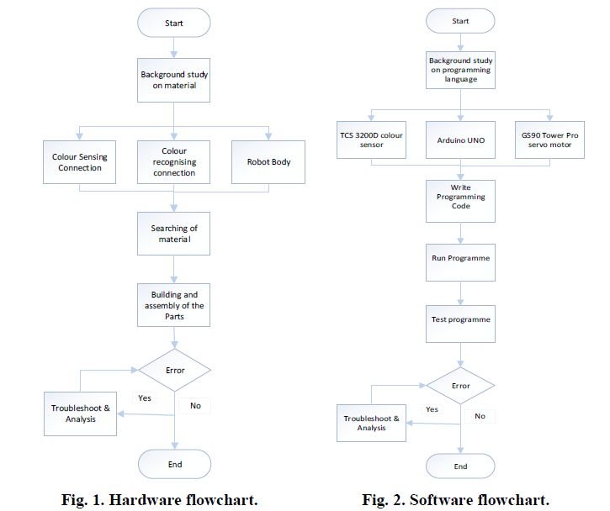

**Applications:**

* The color Sorting Machine can be used for Industrial purposes, like sorting different industrial parts according to the colors.
* For sorting skittles, colored balls and M&Ms.
* Can be used in Automobile Industries.